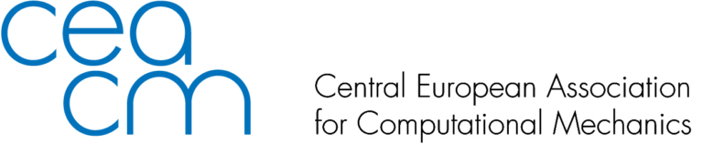

Nomination to CEACM Young Researcher Award 2022

Please send this form by e-mail no later than January 31, 2022 to CEACM Board Members : 'Adnan Ibrahimbegovic' <adnan.ibrahimbegovic@utc.fr>,’Dr. Lógó János’ <logo@ep-mech.me.bme.hu>, 'Bernhard Pichler' <Bernhard.Pichler@tuwien.ac.at>, 'Polach Pavel' <polach@vzuplzen.cz>,'Jože Korelc' <joze.korelc@fgg.uni-lj.si>,'Justín Murín' <justin.murin@stuba.sk>, 'Zdenko Tonković' <zdenko.tonkovic@fsb.hr>

Name of the nominee:

Affiliation:
e-mail:
Name of the award: CEACM Young Researcher Award
Motivation summary (no more than 450 words):

Thesis supervisor(s):
1. Name: e-mail:
2. Name: e-mail:

Attachments:
• Letters of support by thesis supervisors
• CV of the nominee
• Photograph

Rules for Nominations:
-The CEACM Board calls each year for nominations for ECCOMAS Best Thesis Award.
-These nominations will automatically be included for CEACM Young Researcher Award
-Nominator should be thesis advisor(s) who will submit support letter(s)
-Nominator should submit a CV of the nominee.

