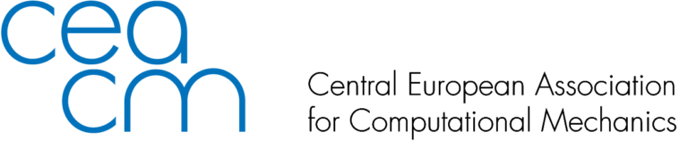

Nomination to CEACM Awards 2022

Please send this form by e-mail no later than January 31, 2022 to CEACM Board Members : 'Adnan Ibrahimbegovic' <adnan.ibrahimbegovic@utc.fr>,’Dr. Lógó János’ <logo@ep-mech.me.bme.hu>, 'Bernhard Pichler' <Bernhard.Pichler@tuwien.ac.at>, 'Polach Pavel' <polach@vzuplzen.cz>,'Jože Korelc' <joze.korelc@fgg.uni-lj.si>,'Justín Murín' <justin.murin@stuba.sk>, 'Zdenko Tonković' <zdenko.tonkovic@fsb.hr>

Name of the nominee:

Affiliation:
e-mail:
Name of the award: CEACM Prof. Mang Award or CEACM Computational Mechanics Award
Motivation summary (no more than 450 words):

Supporting references from:
1. Name: e-mail:
2. Name: e-mail:
3. Name: e-mail:

Attachments:
• 3 Letters of support
• CV of the nominee
• Photograph

Rules for Nominations:
-The CEACM Board calls each year for nominations from any CEACM and other member.
-Nominator should submit a nomination form with 3 support letters and a CV of the nominee.
-Nominator may nominate no more than one nominee for each of the Awards.
-Support letters with no number restriction are accepted from any CEACM and other member.
-Self-nominations are not accepted.
-The CEACM Board appoints CEACM Award Committee each year.
-Nominated members of the CEACM Board cannot participate in Award Committee.
-All CEACM members should respect the voting process with no interfering.

